MOCCal TUTORIAL

**GUI #1.** The first GUI will ask you for your Enhanced Duty Cycle (EDC) delay coefficient. This value is instrument-dependent and will typically fall between 1.4-1.6.

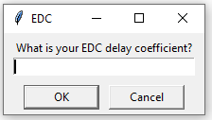

**GUI #2.** The second GUI will facilitate data importation. For CCS Calibration, reference standards from each biomolecular class of interest will need to be chosen. Standards should ideally cover the mass ranges of experimental analytes. Calibrant solutions should be collected via infusion

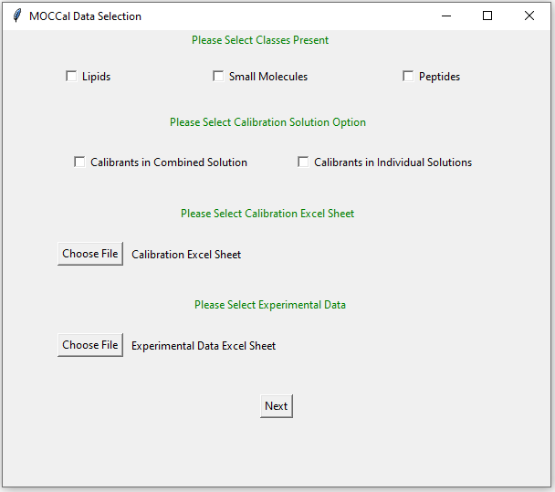

**GUI #2A.** The first selection option allows for you to choose which classes are present in your data. The choices are Lipids, Small Molecules, and Peptides, with “Peptides” having the functionality to calibrate singly, doubly, and triply charged peptides. Standards are required for each class chosen. You may choose any combination of these classes, as long as you have corresponding calibration data.

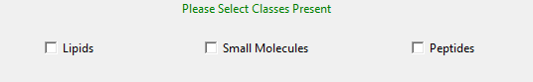

**GUI #2B**. Calibration standards can be prepared either in individual class-specific solutions or in one combined solution. Select the way your calibration solution was prepared, as this will be the composition of your raw data



**GUI #2C.** For calibration data, you will need to upload an excel document containing the calibrant name, *m/z* value, reference literature ccs value, biomolecular class (“lipid”, “small molecule”, or “peptide”), and charge (1-3). A blank template (Calibration_Template.xlsx) and an example excel sheet (Calibration_Example.xlsx) can be found in the Templates_Examples folder.

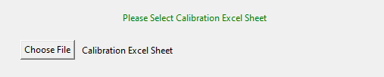



**GUI #2D.** Experimental data can be uploaded as a vendor-specific processed excel file. You will need to upload the data as an excel file containing a compound name (does not have to be a compound identity, just any data-identifying name), *m/z* value, retention time value, and drift time value. A blank template (Experimental_Data_Template.xlsx) and an example excel sheet (Experimental_Data_Example.xlsx) can be found in Templates_Examples folder.

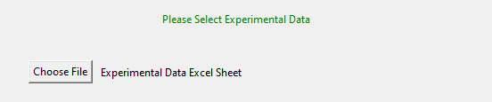



**GUI #3 (Calibrants in Combined Solution).** If you are using calibrants in a combined solution, you will need to upload the raw data file collected on the calibrants as a .mzML file. An example .mzML data file for a combined solution of lipid, small molecule, and peptide standards can be found in the Templates_Examples folder.

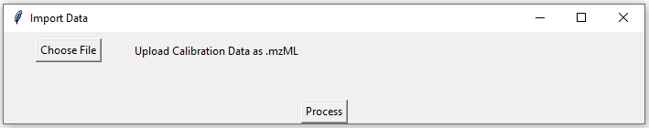

**GUI #3 (Calibrants in Individual Solutions).** If you are using calibrants in individual class-specific solutions, you will need to upload the raw data files collected for each class as .mzML files. Only the classes selected in GUI #2A will appear. Example .mzML data files for individual class-specific solutions for lipid, small molecule, and peptide standards can be found in the Templates_Examples folder.

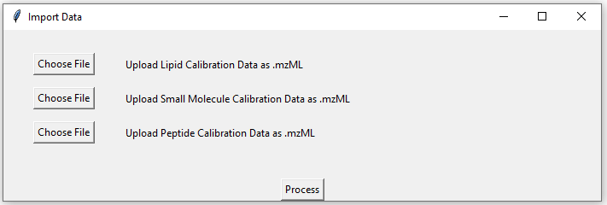

**GUI #4.** After pressing the “Process” button, MOCCal will process the data. When the data processing is complete, the message below will pop up. There will be an excel file titled “CalibrationOutput” in the Output folder containing the processed data.

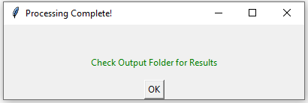

**OUTPUT EXAMPLE**

For every class selected in GUI #1, there will be a corresponding calibration sheet in the output excel document containing the parameters for the optimized calibration curve as well as the calculated CCS values and CCS % error (seen as residuals) as compared to the provided literature CCS values.

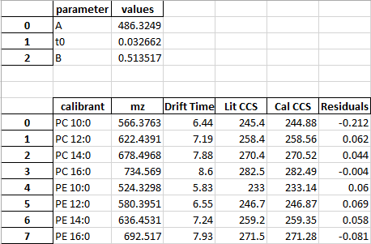

For experimental data, there will be a corresponding sheet in the output excel document containing the DEIMoS extracted drift time and the MOCCal class assignment, class-specific calculated CCS value, and the calibration effect. An example output excel sheet (CalibrationOutput_Example).xlsx can be found in the Templates_Examples folder.

